**Power Query Editor Assignment**

### **1. Remove Unnecessary Columns**

**Question: Remove the Row ID column from the dataset.**

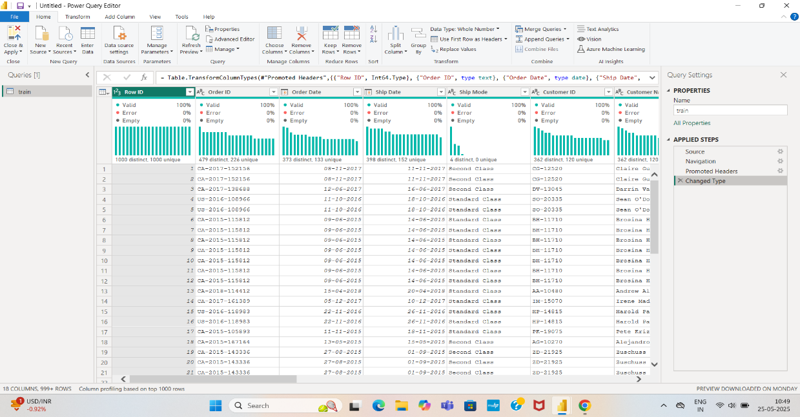

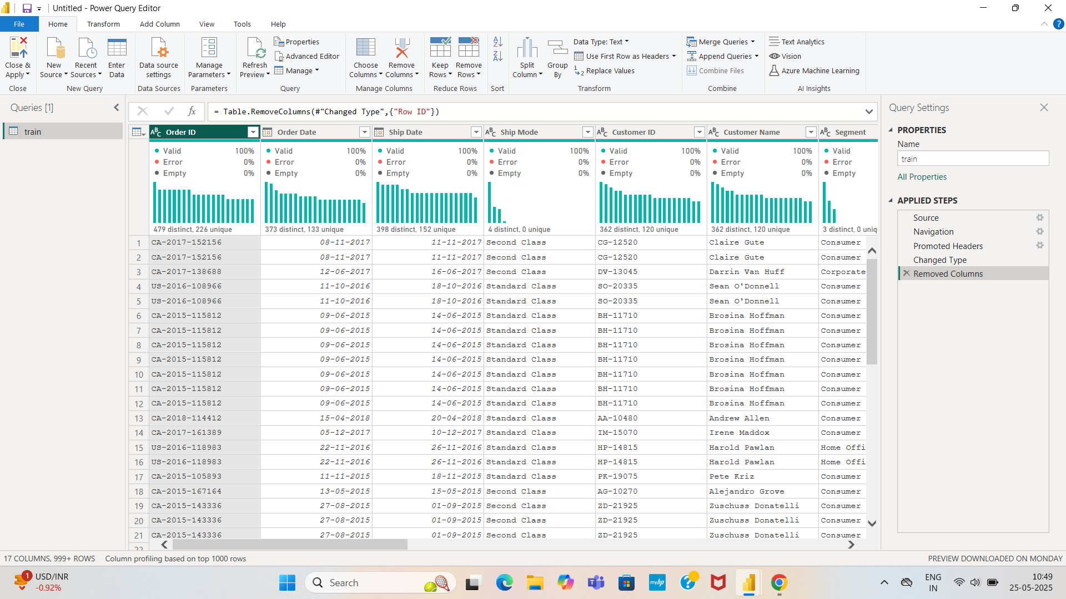

### **2.Change Data Types**

**Question: Change the data types of the following columns:**

* **Order Date and Ship Date to Date.**

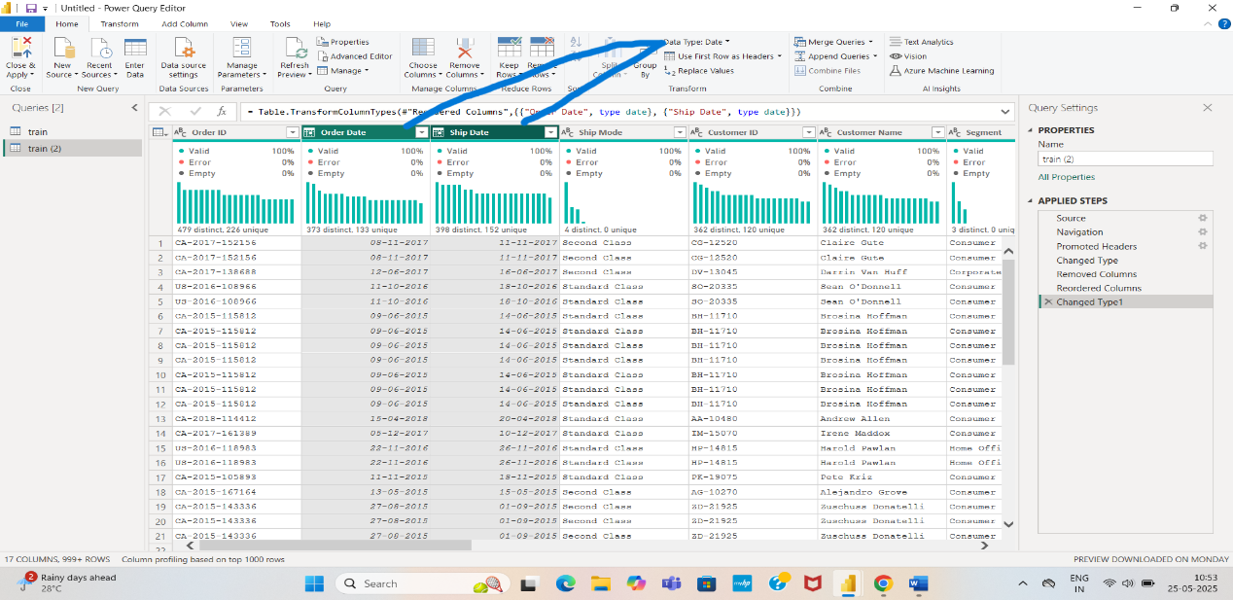

* **Postal Code to Text.**

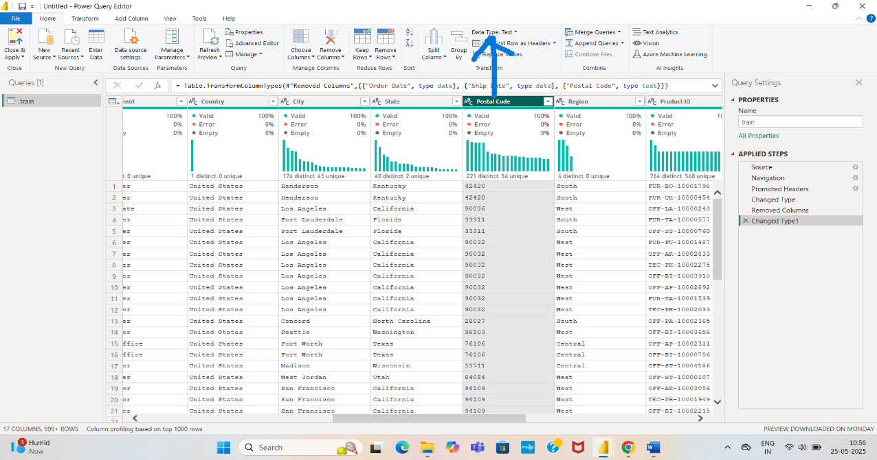

### **3. Rename Columns**

### **Question: Rename the column Sub-Category to Product Subcategory.**

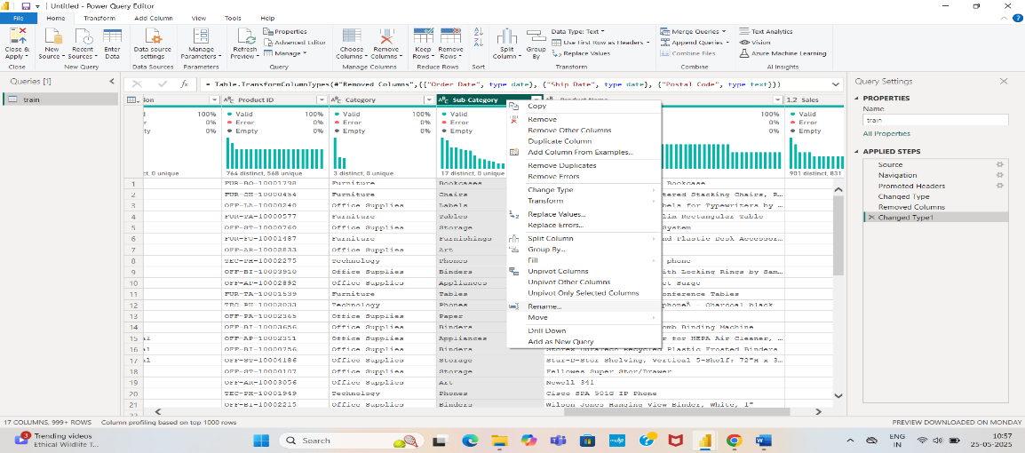

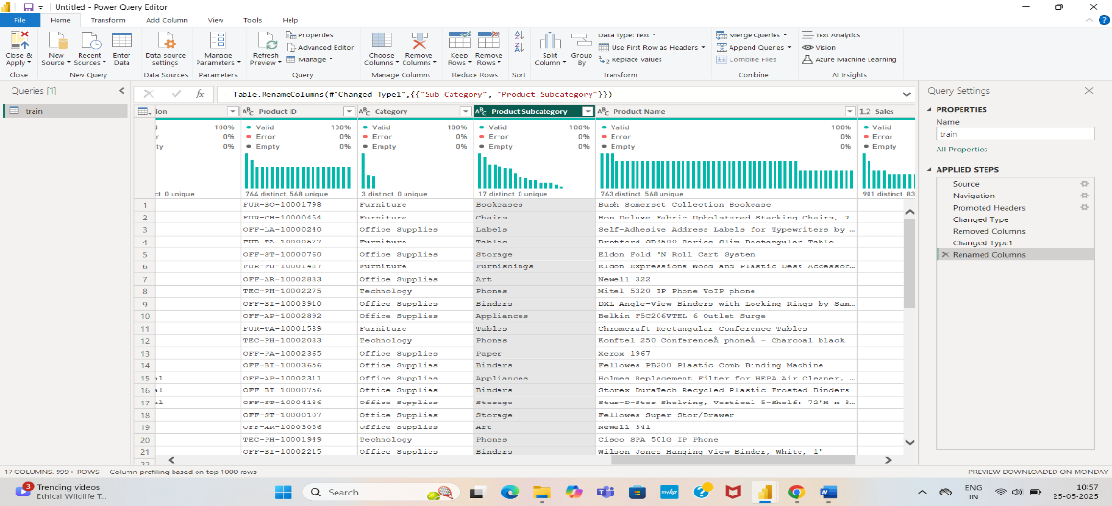

### **4. Split Columns**

**Question: Split the Customer Name column into two new columns: First Name and Last Name.**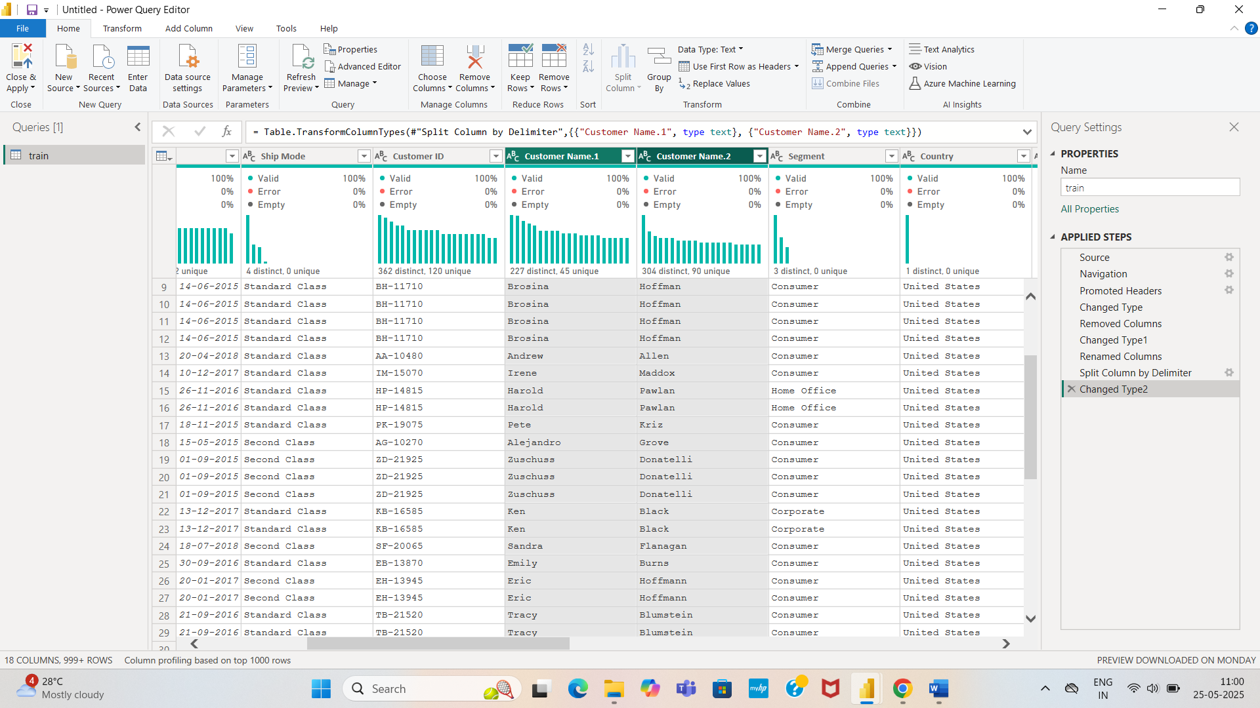

### **5. Merge Columns**

**Question: Combine the City and State columns into a single column named City-State with a comma and a space separator (e.g., "New York, NY").**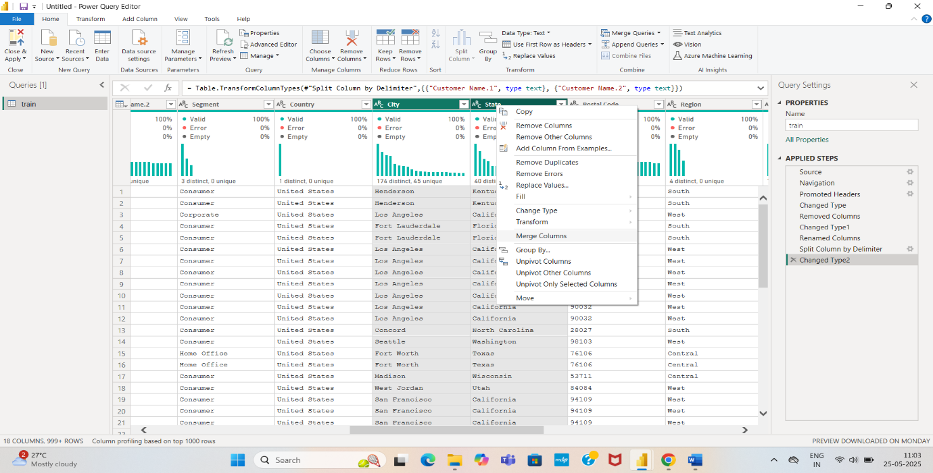

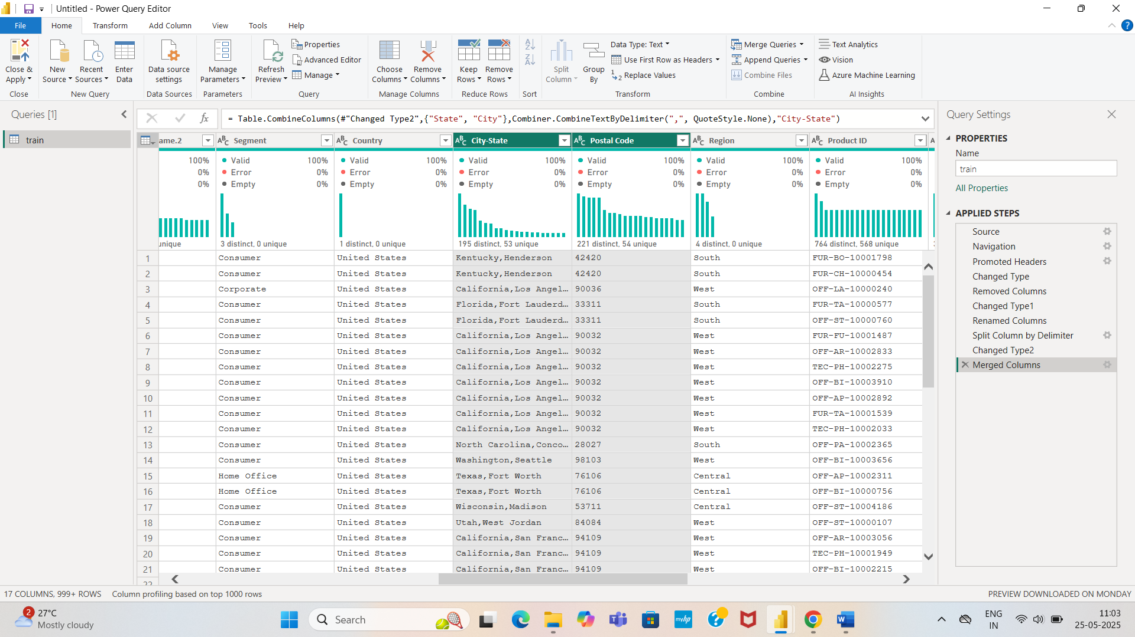

### **6. Replace Values**

**Question: Replace any instance of First Class in the Ship Mode column with Premium Shipping.**

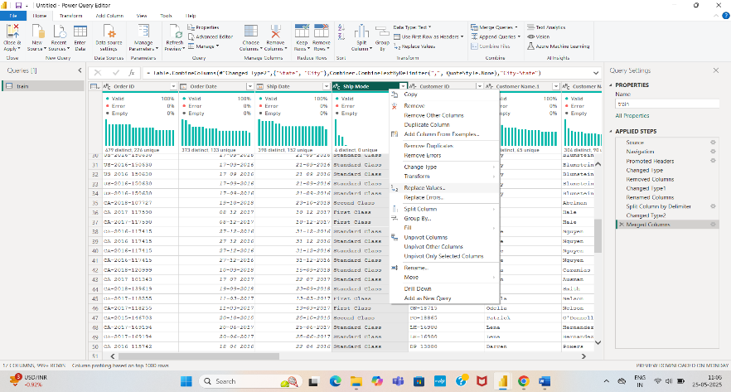

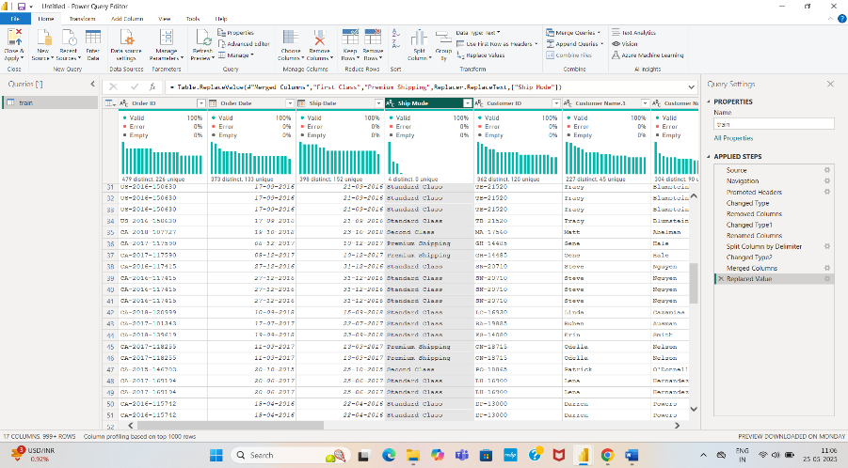

### **7. Remove Duplicates**

**Question: Remove any duplicate rows based on the Order ID column.**

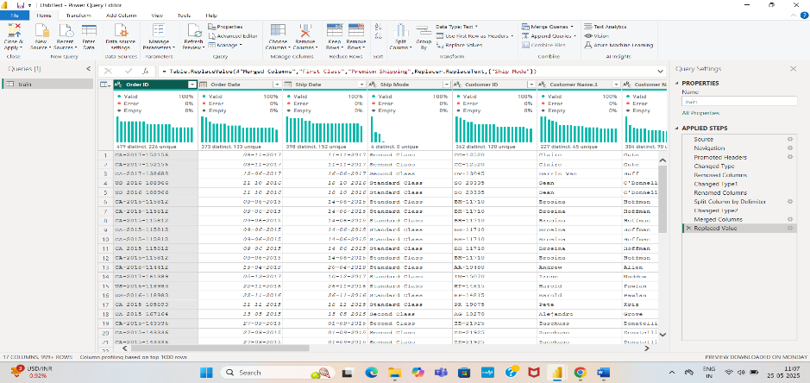

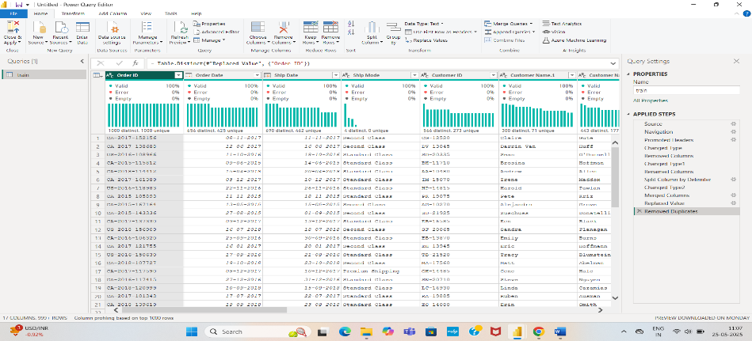

### **8. Filter Rows**

**Question: Filter the data to include only rows where Sales is greater than 500.**

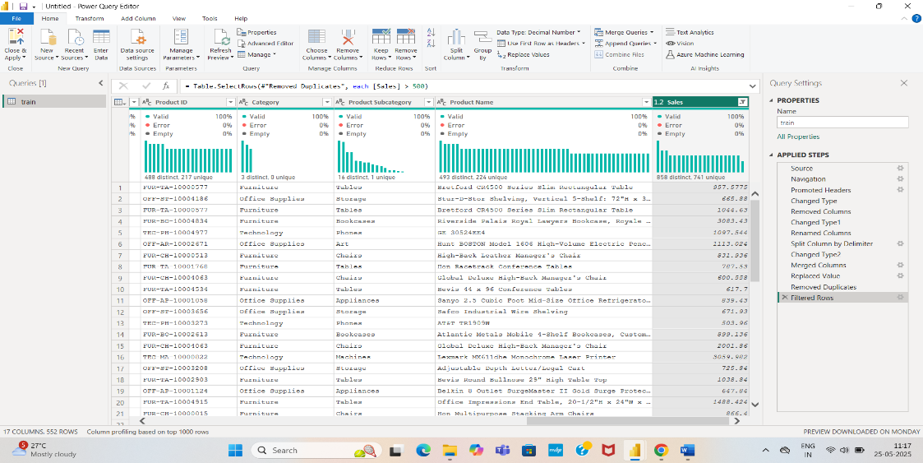

### **9. Sort Rows**

**Question: Sort the dataset by Order Date in ascending order.**

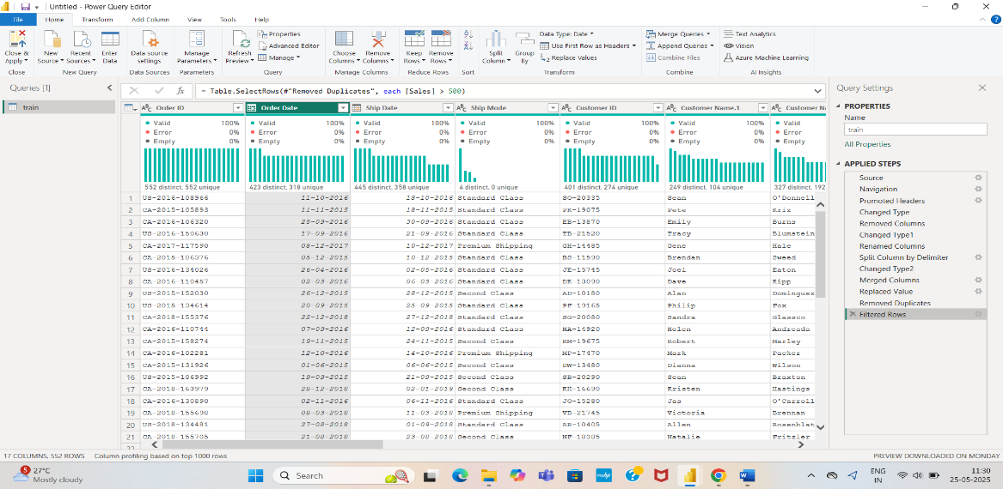

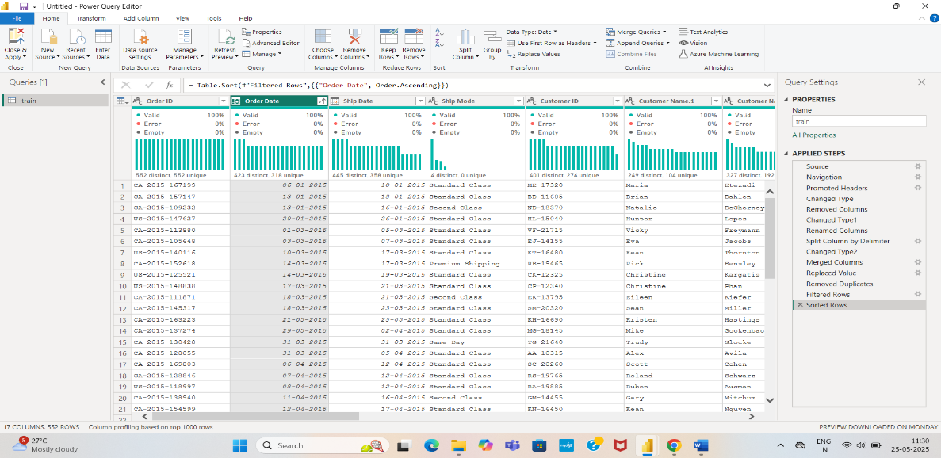

### **10. Add a Conditional Column**

**Question: Add a new column named Profit Category with the following logic:**

* **If Profit is greater than 100, label it "High Profit."**
* **Otherwise, label it "Low Profit."**

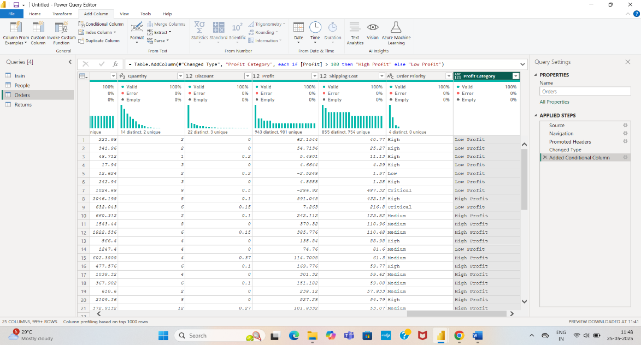

### **11. Calculate a New Column**

**Question: Create a new column called Total Cost, calculated as Sales minus Profit.**

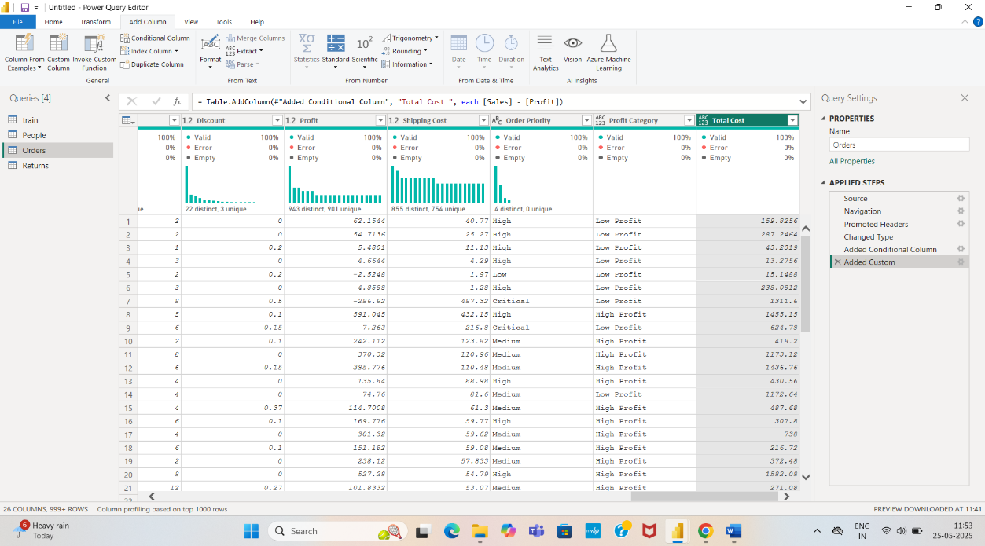

### **12. Group Data**

**Question: Group the data by Category and calculate the total Sales and Profit for each category.**

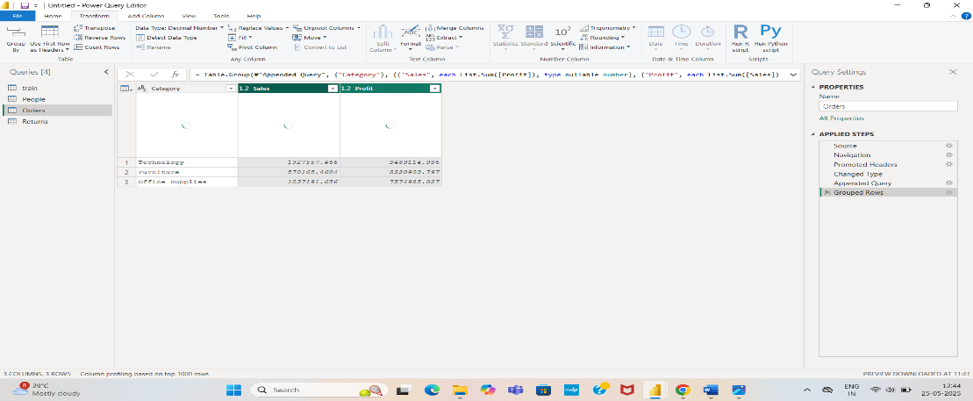

### **13. Pivot Columns**

**Question: Pivot the Ship Mode column to show the count of each shipping method for every Region.**

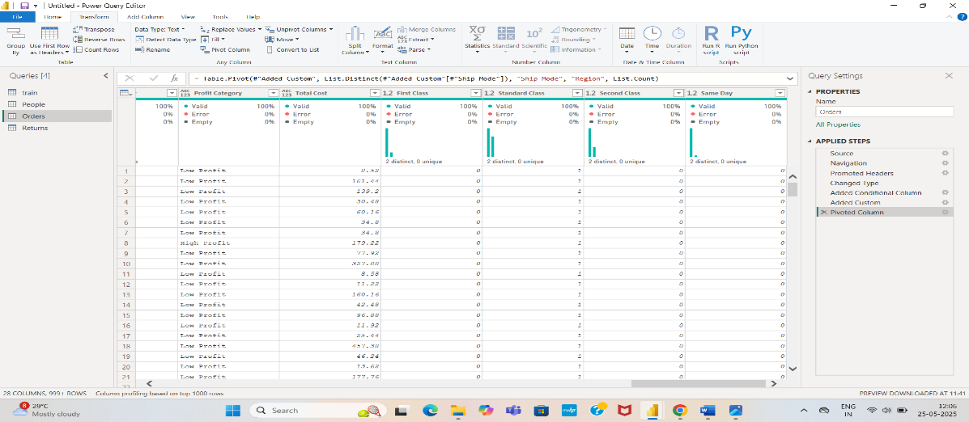

### **14. Unpivot Columns**

**Question: Unpivot the Sales, Profit, and Discount columns so that the data is in long format.**

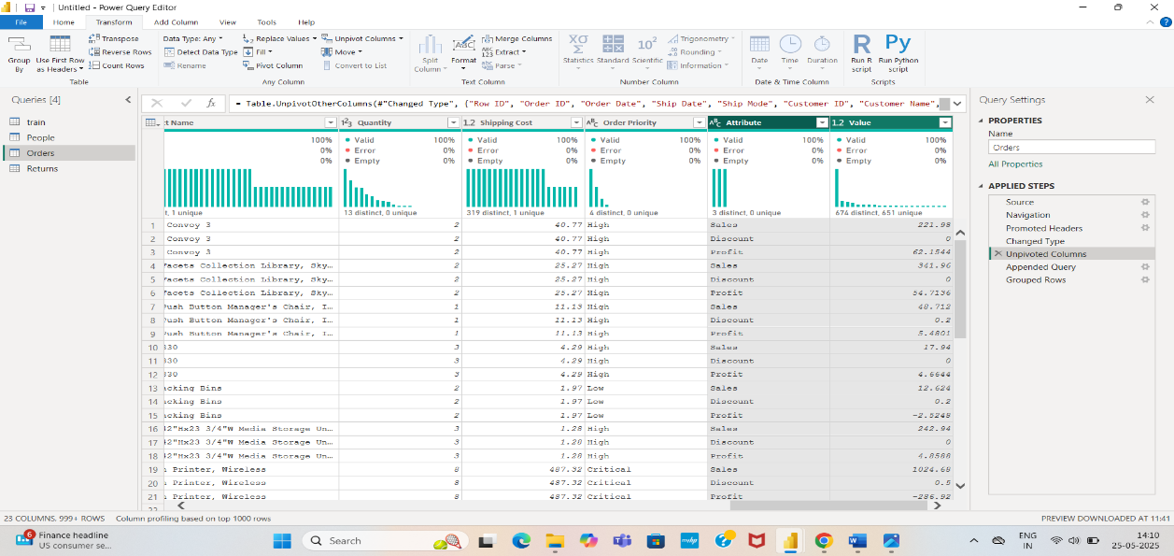

### **15. Filter Top N Rows**

**Question: Display the top 10 rows with the highest Profit.**

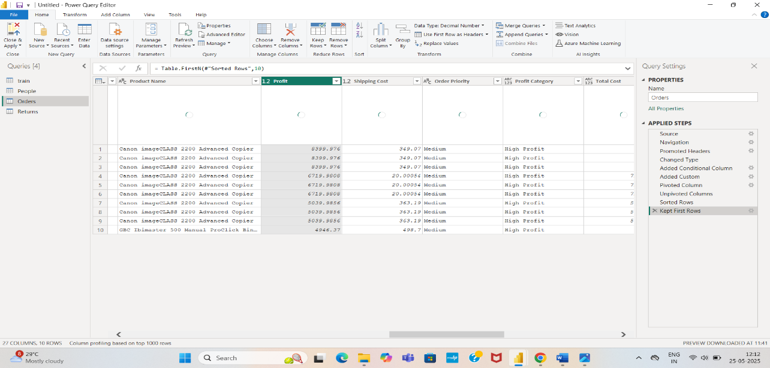

### **16. Replace Errors**

**Question: Identify any errors in the Quantity column and replace them with a default value of 1.**

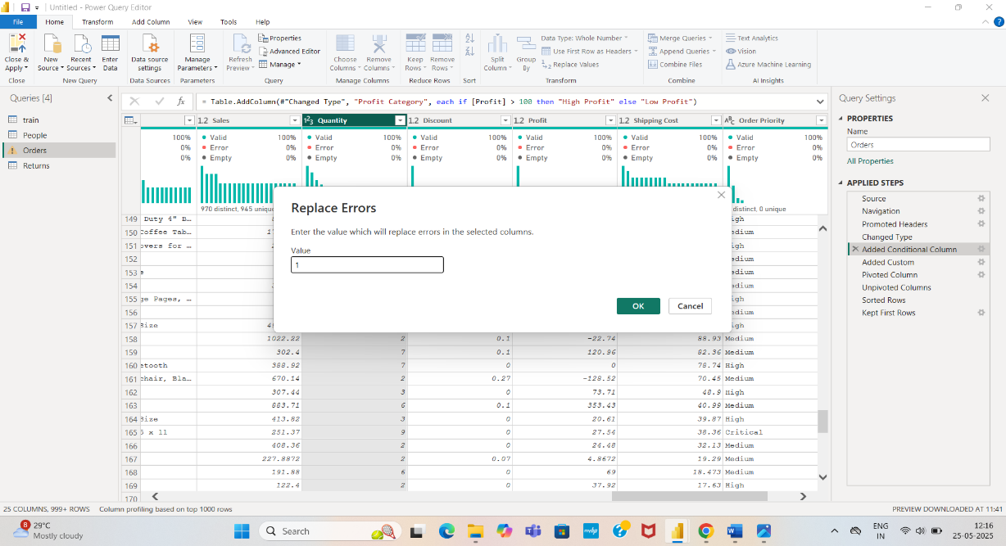

**17. Remove Null Values**

### **Question: Remove rows where the Customer Name or Product Name columns have null values**

### **18. Extract Text**

**Question: Extract the first three letters of the Order ID column into a new column**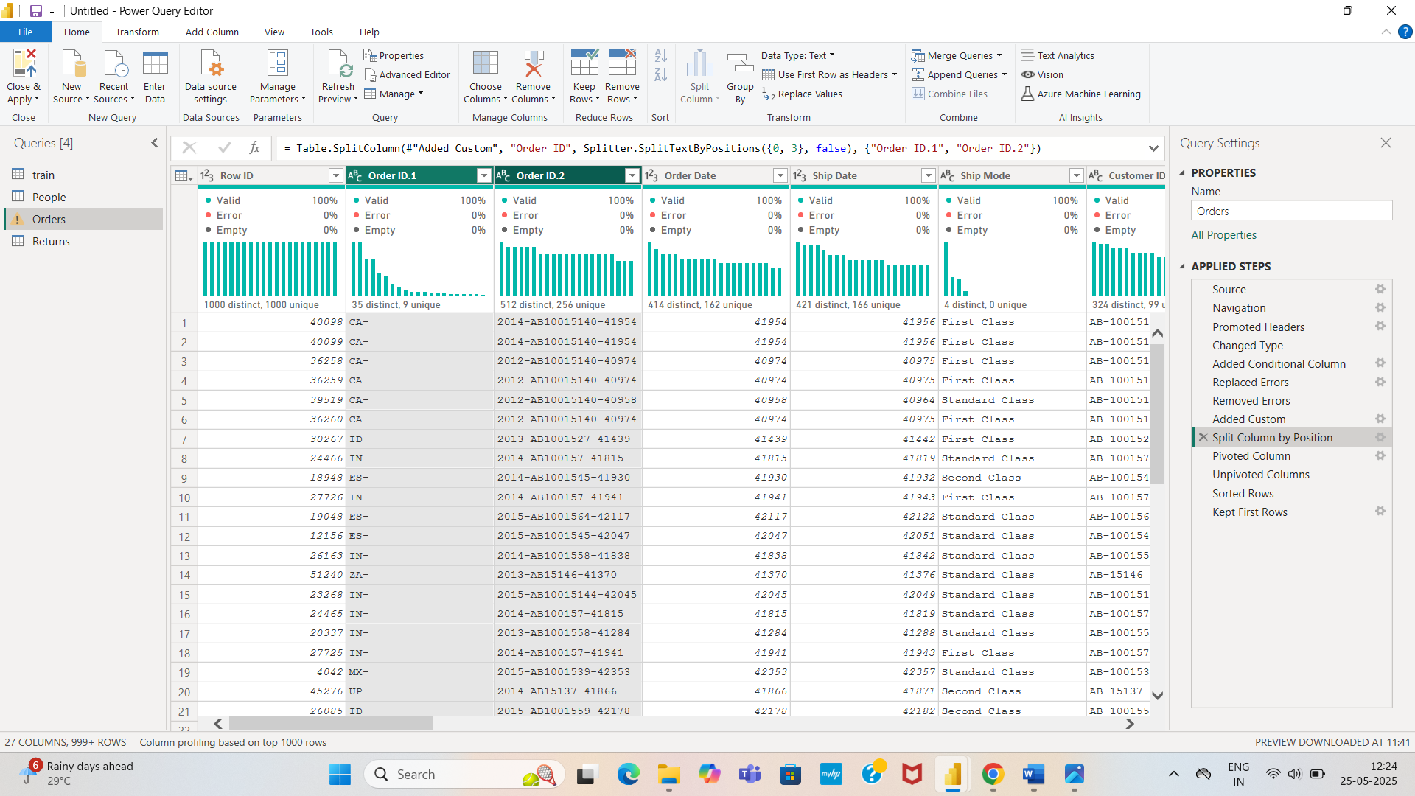

### **19. Add Index Column**

**Question: Add an index column starting from 1.**

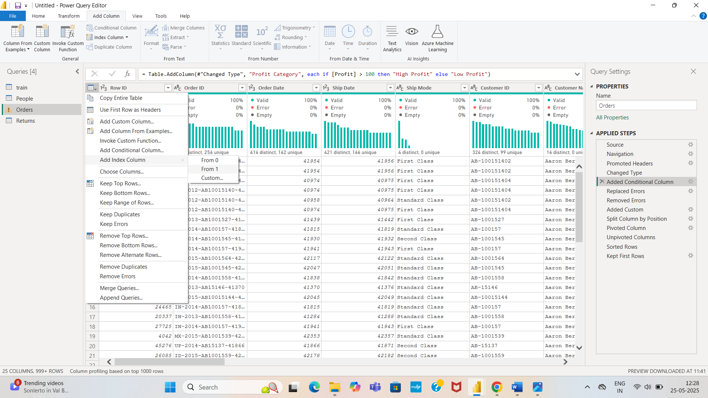

### **20. Append Queries**

**Question: Create a second table with the same structure and append it to the Orders table.**

